## Front End Engineering-II /Artificial

## Intelligence and Machine Learning

Project Report

Semester-IV (Batch-2022)

DONILA WEDDING HOUSE



**Supervised By: Submitted By:**

Faculty Name Tanish Dalal(2210990888)

G-13

Raveesh Samkaria

**Department of Computer Science and Engineering**

## Chitkara University Institute of Engineering & Technology,

## Chitkara University, Punjab

**Abstract**

Donilla Wedding House is an enchanting online platform that caters to individuals embarking on their journey towards a dream wedding. With a focus on timeless elegance and personalized experiences, Donilla offers a curated collection of wedding inspiration, planning tools, and a network of top-tier vendors to assist couples in creating their perfect day. Employing modern web design techniques like semantic HTML and CSS Flexbox, the website ensures optimal viewing across diverse devices. Segmented into multiple pages, each section is dedicated to distinct facets of the venue, ranging from wedding planning services to insightful blog updates. The platform features an interactive community hub for connecting with like-minded individuals, a bridal boutique showcasing the latest trends, and expert guidance to ensure a seamless and memorable wedding planning process. Donilla Wedding House is designed to be a one-stop destination where dreams unfold and love stories come to life.

# TABLE OF CONTENTS

|  |  |  |
| --- | --- | --- |
| **Sr.no** | **Section** | **Page No** |
| **1.** | Introduction | 4 |
| **2.** | Problem Statement | 5 |
| **3.** | Technical Details | 6 |
| **4.** | File Structure | 7 |
| **5.** | Result | 8 |
| **6.** | References | 36 |

**Introduction**

Welcome to the enchanting world of Donilla Wedding House, where the narrative of your love story unfolds seamlessly through the intricate synergy of HTML and CSS. Within this digital realm, we offer more than just a wedding planning platform; it's a dynamic canvas, meticulously crafted with elegance and a personalized touch, all made possible by the magic woven by HTML and CSS.

In the architecture of our platform, HTML serves as the fundamental backbone, shaping the essence of your wedding journey with precision and structure. It ensures that your exploration is not just smooth but also immersive, with each element thoughtfully placed to enhance your overall experience. Meanwhile, CSS steps in as our artistic palette, contributing strokes of sophistication and style to your dream wedding. It touches everything from the delicate fonts that narrate your unique story to the responsive design, adapting seamlessly to every device and screen size.

Beyond the surface aesthetics, the use of HTML and CSS extends to the very core of crafting an interactive and personalized experience for you. Whether you find inspiration in our curated collections, engage with our intuitive planning tools, or connect with our vibrant community, HTML and CSS work harmoniously, creating a user-friendly interface that empowers you to take control of your wedding vision.

Embark on the journey of a lifetime with Donilla Wedding House, where the harmony of HTML and CSS transforms the pixels into a captivating digital reality. Your love story deserves nothing less than the perfect canvas, and with HTML and CSS as our tools, we stand ready to ensure that every pixel resonates with the beauty of your unique journey.

# Problem Statement

In the realm of design agencies, establishing a compelling online presence is crucial for attracting prospective clients and showcasing the agency's unique offerings and capabilities. However, creating a front-end website that effectively communicates the agency's brand identity, services, and portfolio while ensuring a seamless user experience poses several challenges.

Firstly, design agencies often struggle to strike the right balance between creativity and functionality in their websites. While it's essential to showcase the agency's creative flair through visually stunning designs, it's equally important to ensure that the website is easy to navigate and provides clear, concise information to visitors.

Secondly, designing a responsive website that adapts seamlessly to various devices and screen sizes presents a significant challenge. With the proliferation of mobile devices and tablets, users expect a consistent and optimized browsing experience across all platforms. Failure to deliver this can result in a loss of potential clients and credibility for the agency.

Additionally, ensuring accessibility for all users, including those with disabilities, is another pressing concern. Design agencies must adhere to accessibility standards to ensure that their websites are usable by individuals with diverse needs, such as screen readers for visually impaired users.

In summary, the problem statement revolves around the need to create a front-end website for a design agency that effectively balances creativity with functionality, offers seamless responsiveness across devices, adheres to accessibility standards, and optimizes performance to provide an exceptional user experience. Addressing these challenges will be critical in achieving the project's objectives and ensuring the success of the agency's online presence.

# Technical Details

The front-end website for the design agency was constructed with a minimalist approach, employing only essential technologies to ensure a streamlined user experience. Here are the primary technical details of the project:

* **HTML Structure:** The website's structure was crafted using semantic HTML markup to enhance accessibility and clarity. Each page was organized with appropriate tags to facilitate straightforward navigation and readability.
* **CSS Styling:** Cascading Style Sheets (CSS) were utilized for styling the website's layout, typography, and color schemes. Custom CSS rules were applied to maintain a consistent visual design across the site while optimizing load times and code simplicity.
* **Responsive Design:** Responsive design principles were implemented to ensure the website's compatibility with various devices and screen sizes. Media queries and flexible layouts were employed to adapt the content and design elements responsively without reliance on frameworks.
* **JavaScript Functionality:** JavaScript was exclusively utilized for essential functionality, primarily for smooth scrolling to different sections of the website via the navigation bar. This lightweight implementation ensured efficient performance without compromising user experience.

**Methodology**

Requirement Analysis: Initiate the project by understanding its requirements and goals. Engage with stakeholders or clients to gather information regarding the business, target audience, desired features, and branding guidelines.

Research and Inspiration: Conduct research on other wedding venue websites to gather inspiration and comprehend current design trends in the industry. Collect ideas for layout, color schemes, typography, and imagery.

Design Mockups: Create design mockups using graphic design software or tools like Adobe XD or Figma. Design the visual elements of the website, including the color palette, typography, images, and overall aesthetics.

HTML Structure: Begin constructing the website's HTML structure based on wireframes and design mockups. Use semantic HTML tags to logically structure the content and improve accessibility and SEO.

CSS Styling: Apply CSS styles to the HTML structure to enhance the visual appearance of the website. Implement the chosen color scheme, typography, layout, and other design elements. Ensure responsiveness by using media queries and CSS frameworks like Bootstrap if necessary.

Content Integration: Populate the website with relevant content, including text, images, and multimedia. Craft compelling copy that effectively communicates the value proposition of Donila Wedding House and its services.

Testing and Debugging: Thoroughly test the website across different devices, browsers, and screen sizes to identify and fix any layout or functionality issues. Ensure that all links, forms, and interactive elements work correctly.

Deployment: Once the website is polished and finalized, deploy it to a web hosting server and make it live for the public to access. Set up the domain name, server configurations, and any necessary security measures.

Maintenance and Updates: Regularly monitor the website for performance issues, security vulnerabilities, and content updates. Stay updated with the latest web technologies and design trends to keep the website fresh and relevant over time.

Following this methodology ensures a structured approach to developing the Donila Wedding House website, resulting in a high-quality end product that meets the project objectives and exceeds client expectations.

**Procedure:**

Certainly! In the HTML structure provided, the document begins with a declaration of the HTML5 document type (DOCTYPE) and sets the language attribute to French (lang="fr"). The <html> tag initiates the HTML document, and within the <head> section, the character encoding is set to UTF-8. Additionally, a viewport meta tag is included to ensure a responsive design. The title of the webpage is defined as "DONILA WEDDING HOUSE," and an external stylesheet file, "style.css," is linked.

Moving into the <body> section, a container div with the id "home-main" is created. This div encompasses the logo section, which includes two logo images and a text element. Following that, the navigation section is formed with the id "row2," containing a navbar with an unordered list of links and a contact section displaying contact information and social media icons. The main section, identified by the id "main," is then structured to include login and search buttons, a large text block, and a "CONTACT US" button.

The structure further unfolds with a transition to the second page, implemented through a section div with the class "Second-page." This section encompasses a decorative line, a heading, an image, a text block, and a "READ MORE" button. The progression continues to the third page with a section div and the class "page3," featuring a decorative line, a heading, a text block, an image and caption section, and a "SEE MORE" button.

Subsequent pages, including the fourth, fifth, and sixth, follow a similar structure with section divs having distinct classes ("page4," "Page5," and "page6," respectively). Each page includes relevant content such as headings, text blocks, buttons, images, and forms, maintaining a cohesive design throughout the website. Finally, the HTML document is concluded.

RESULTS :

HTML

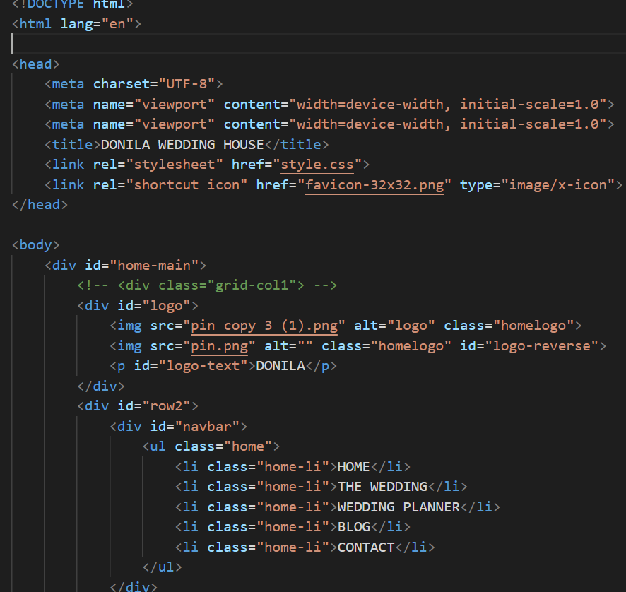

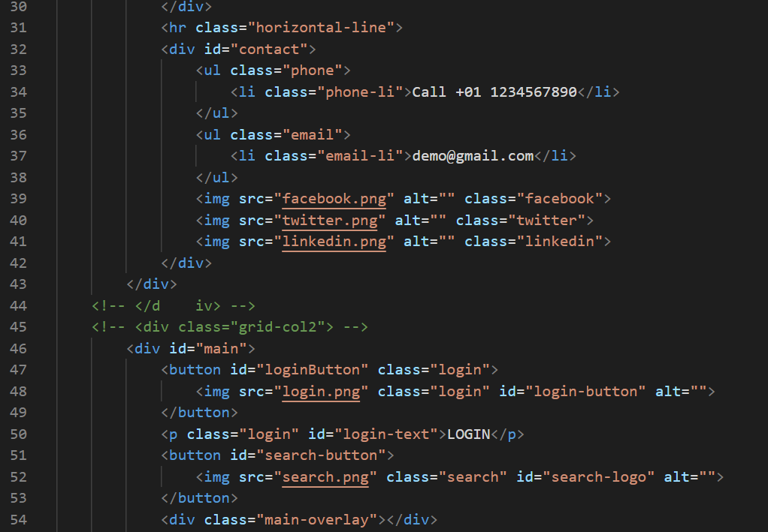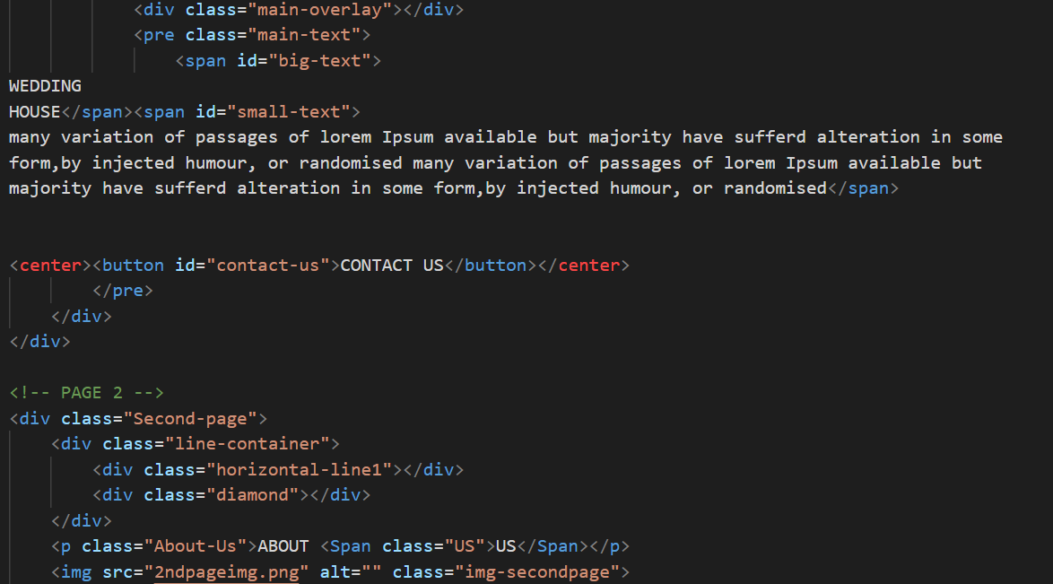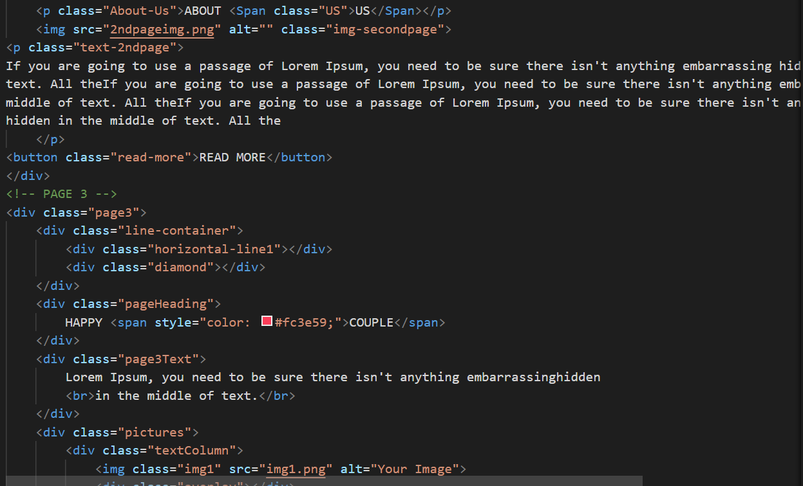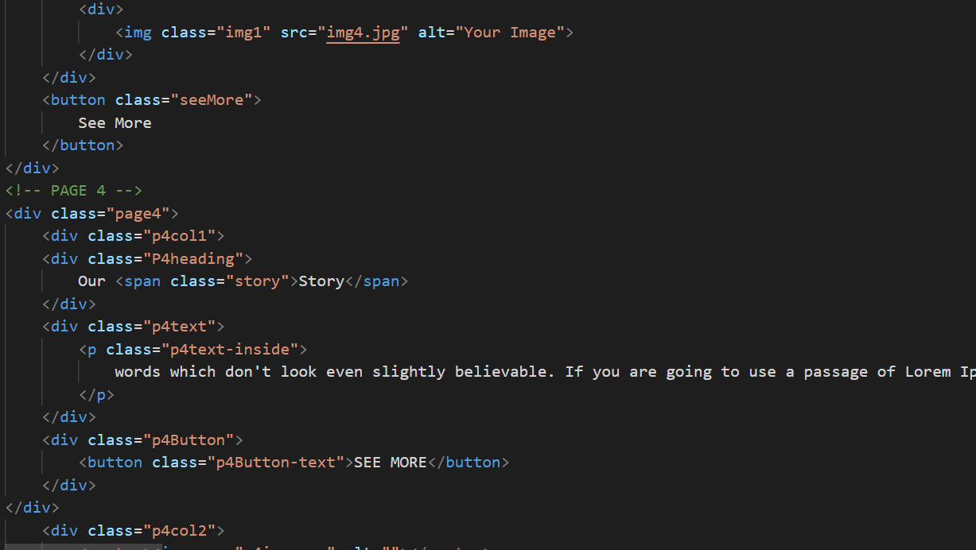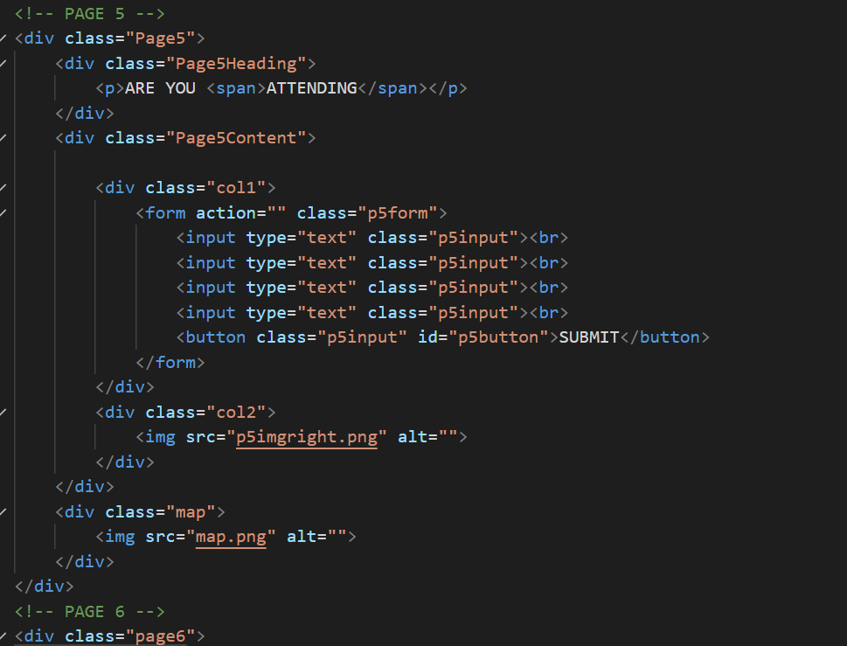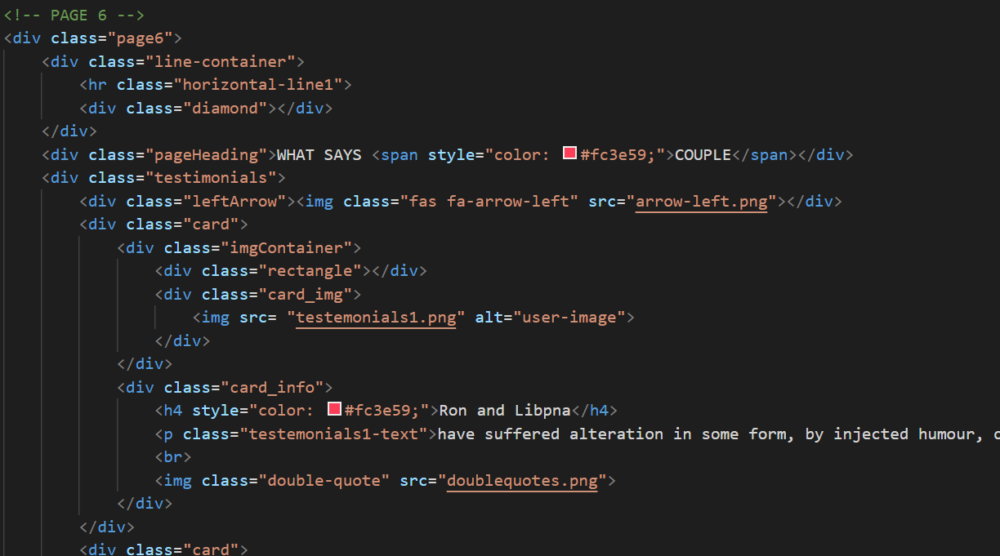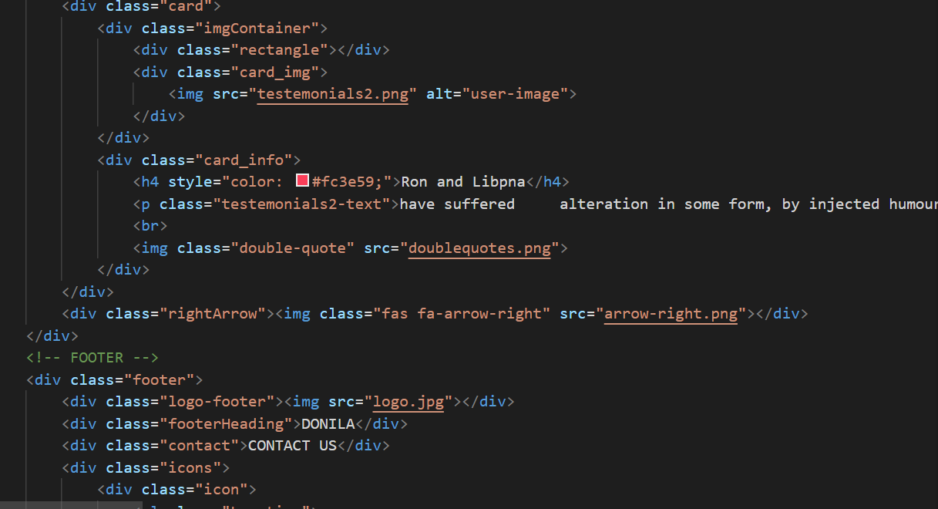

css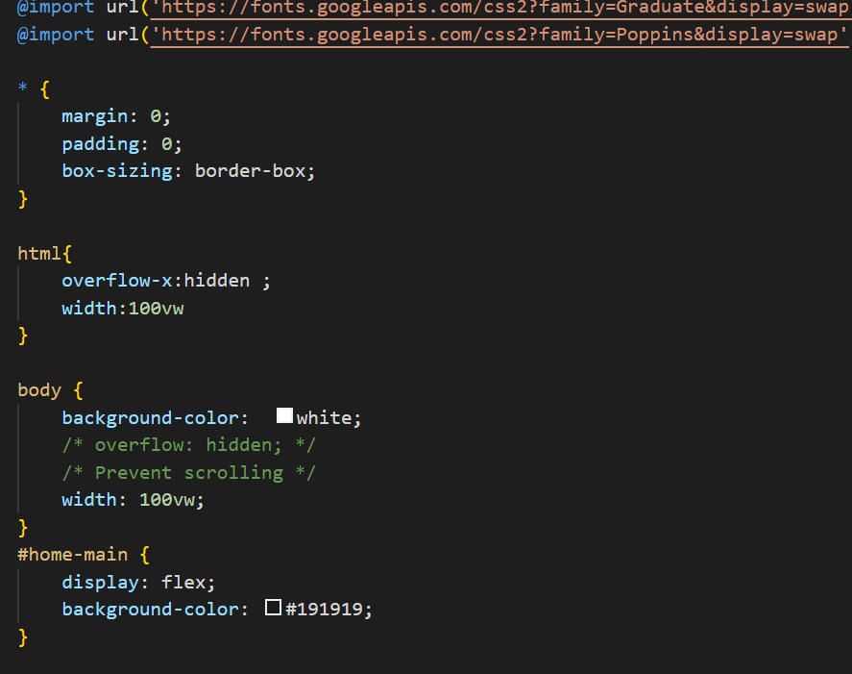

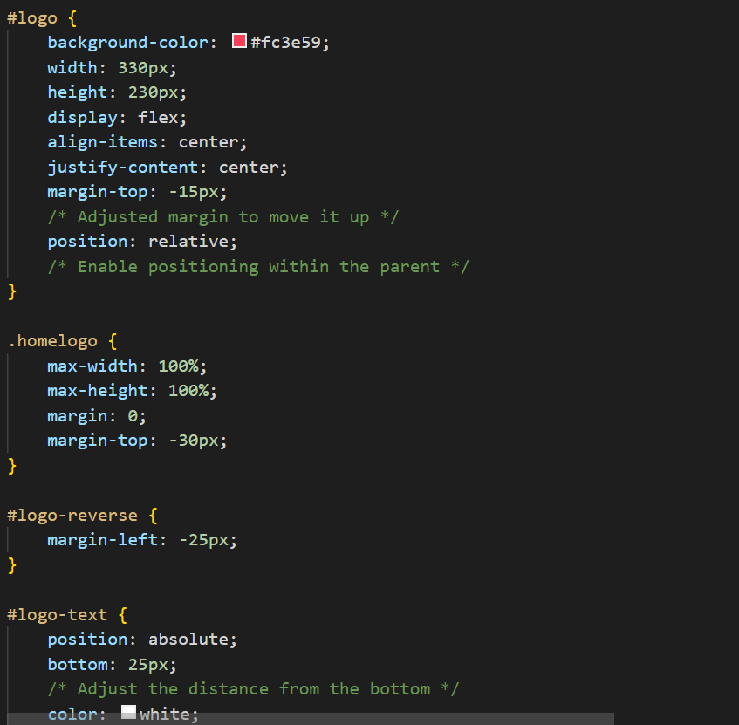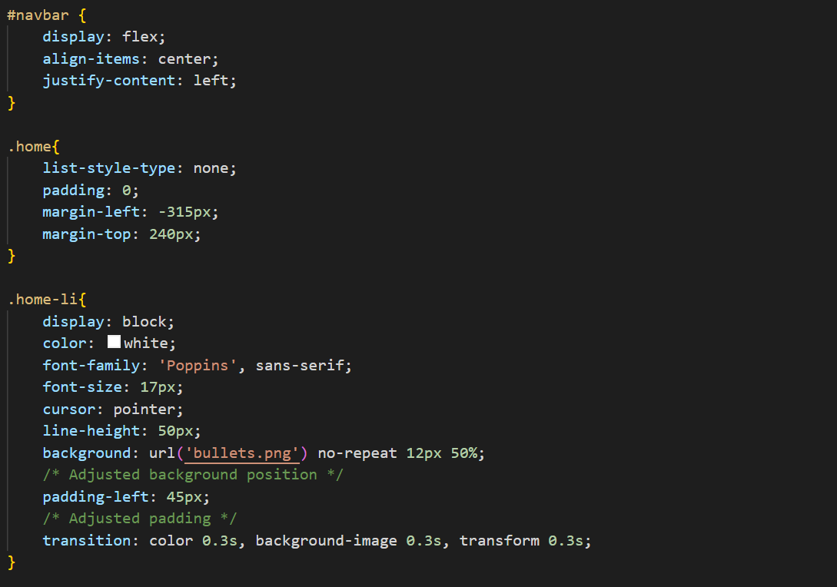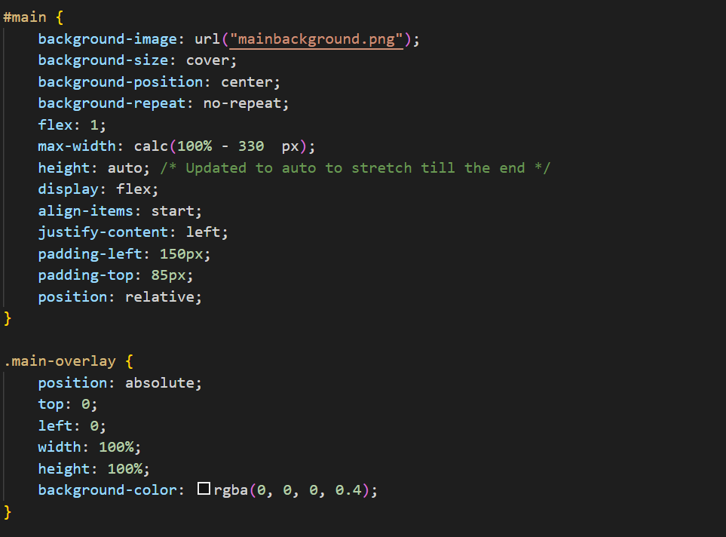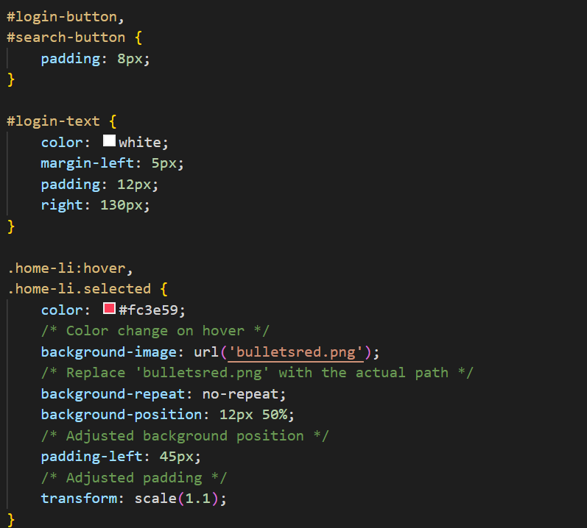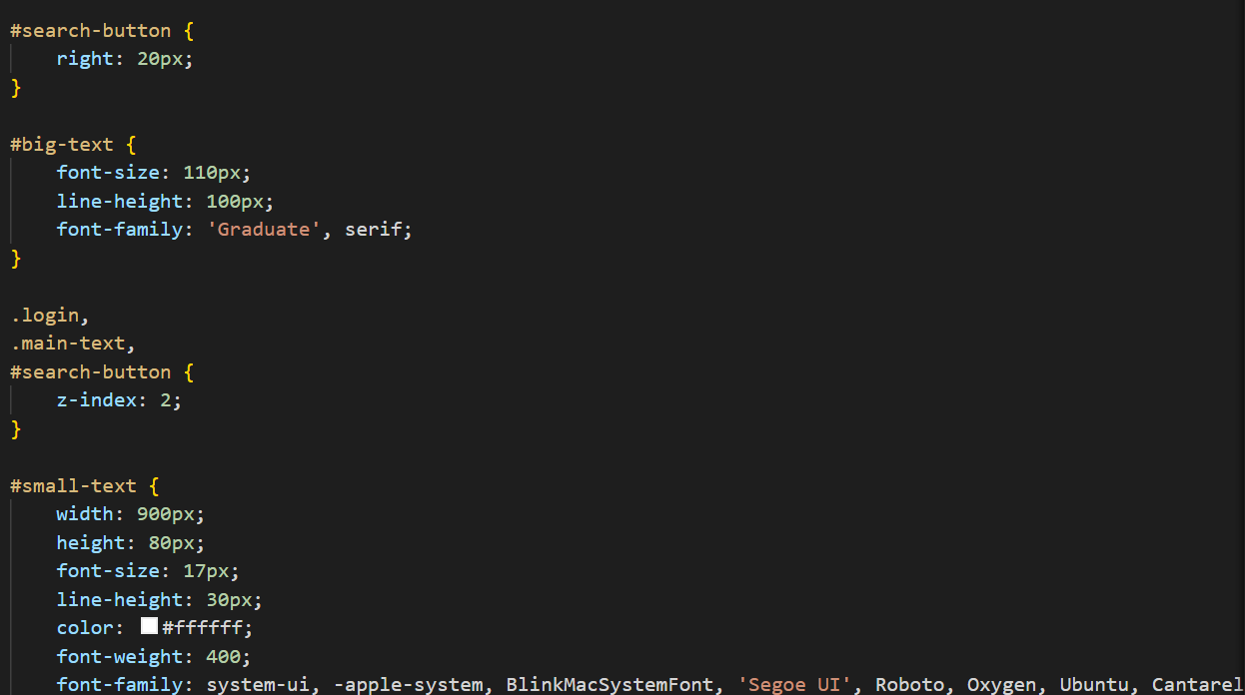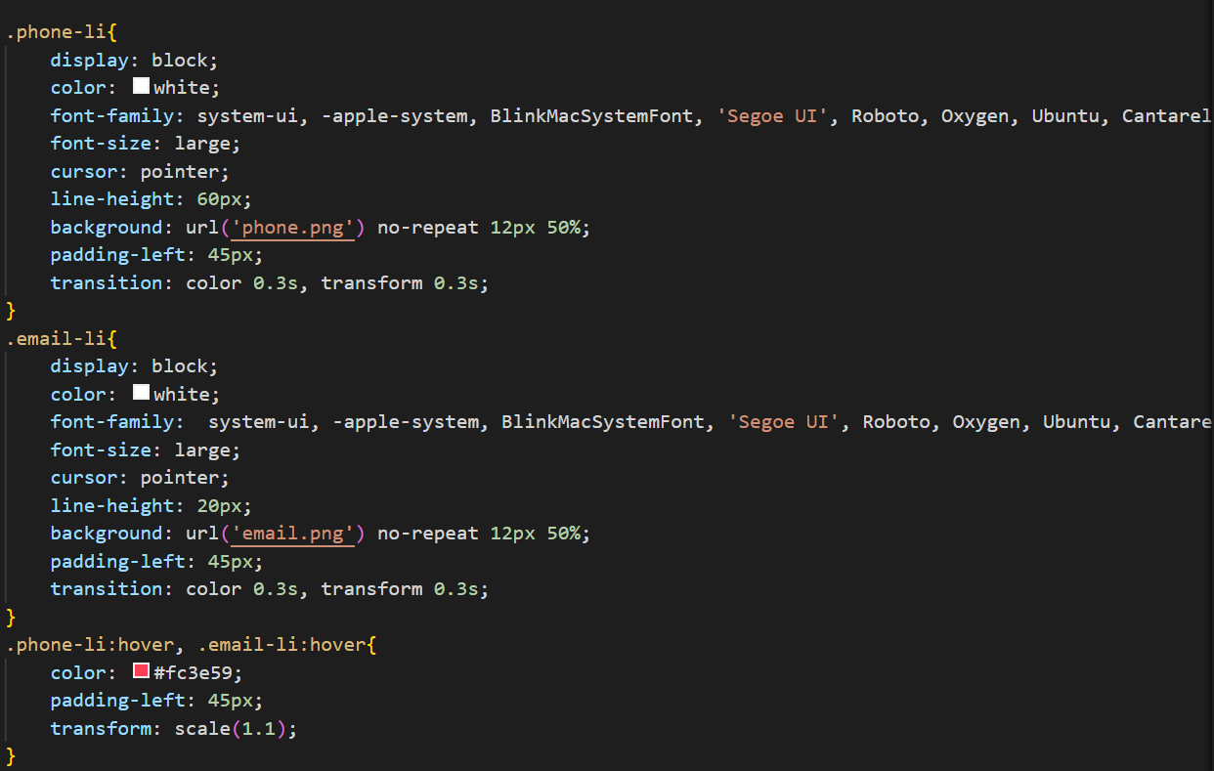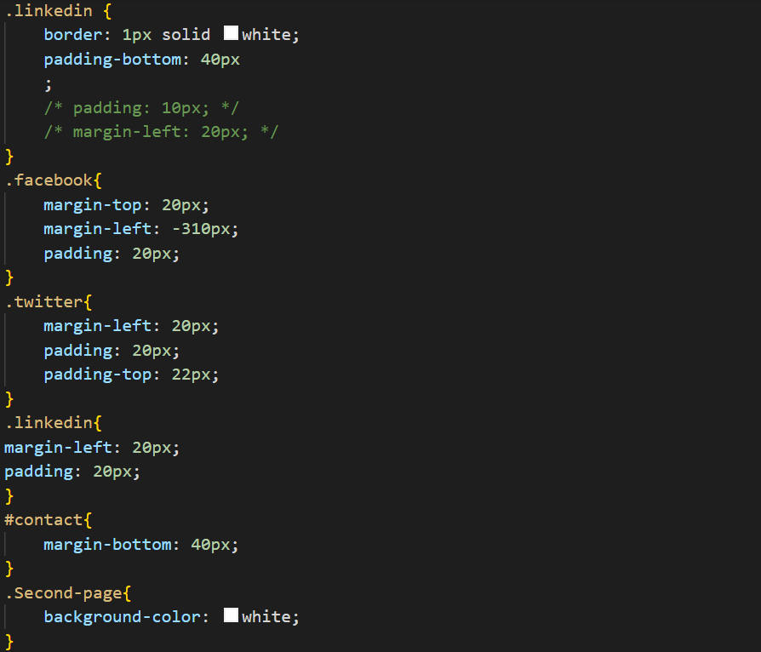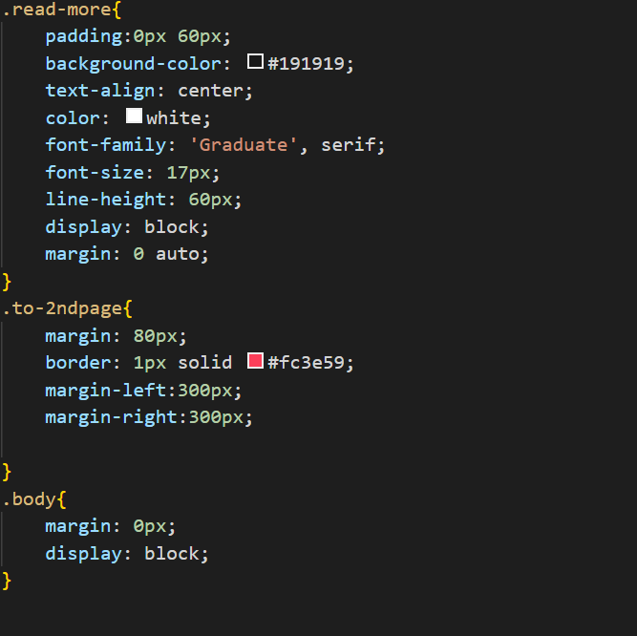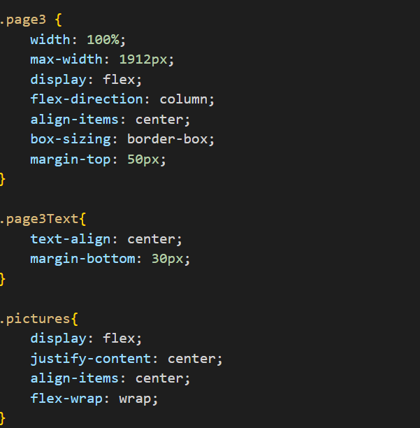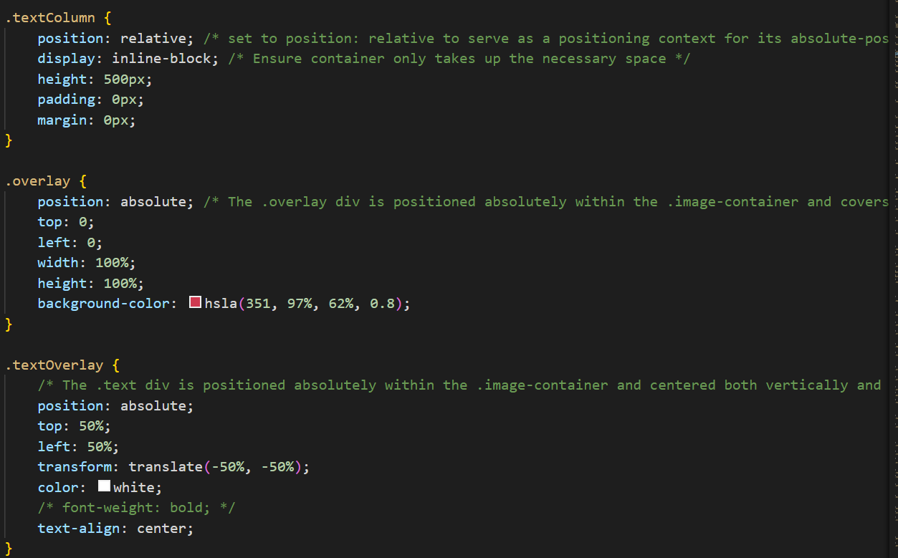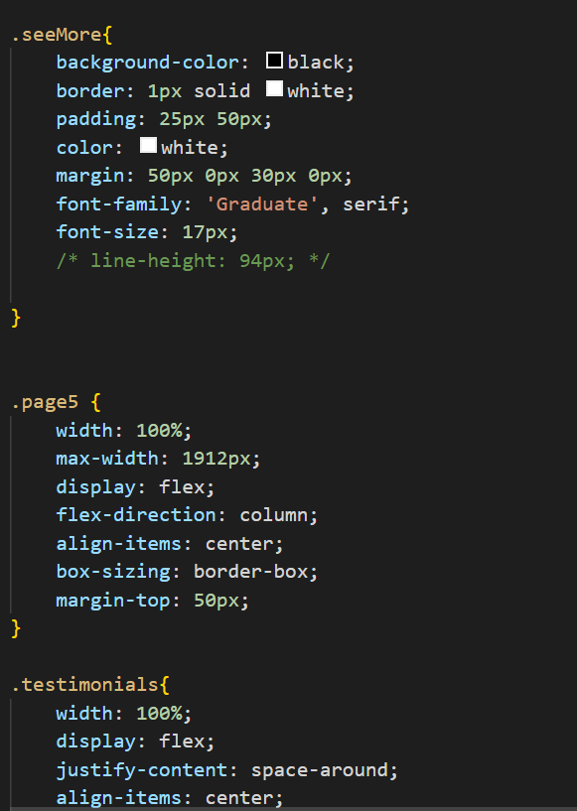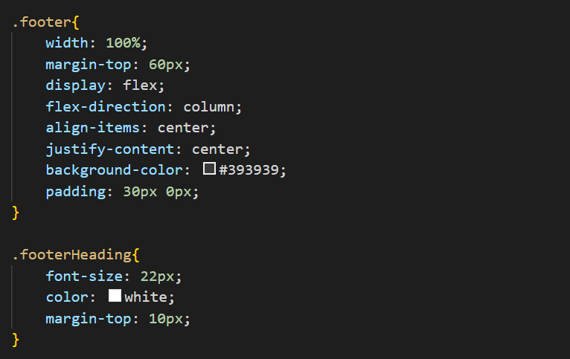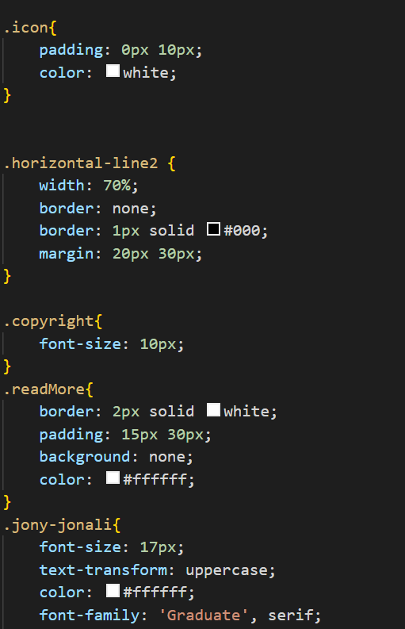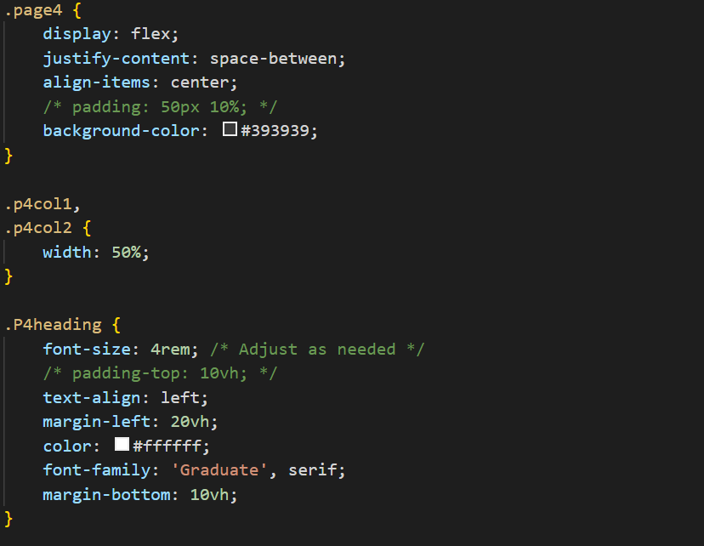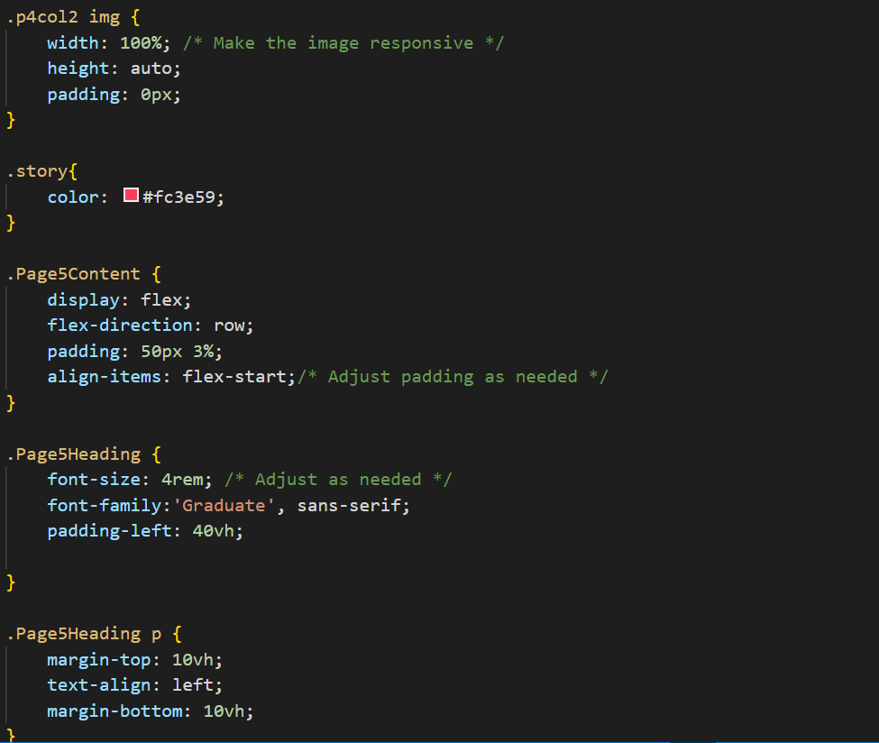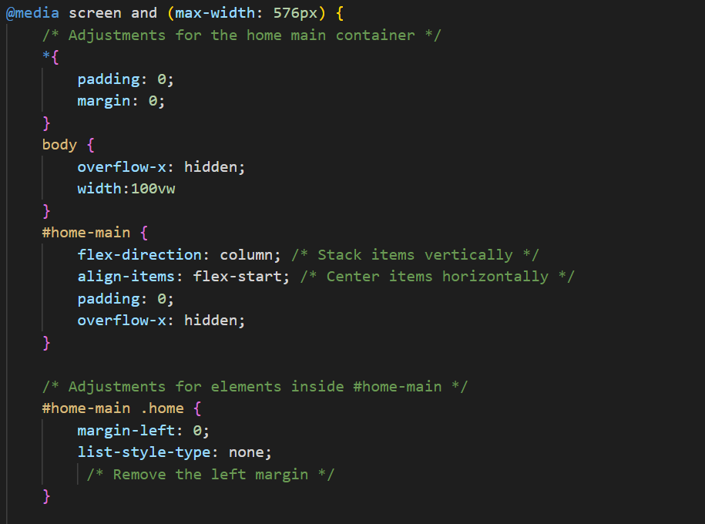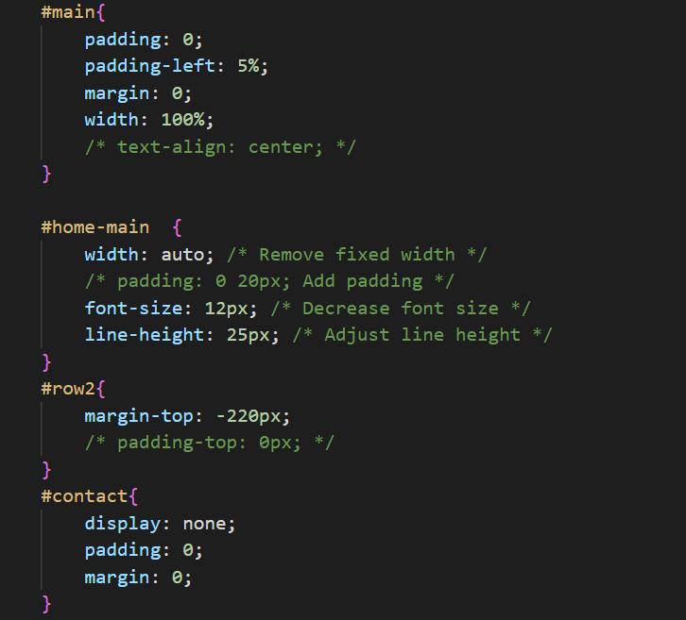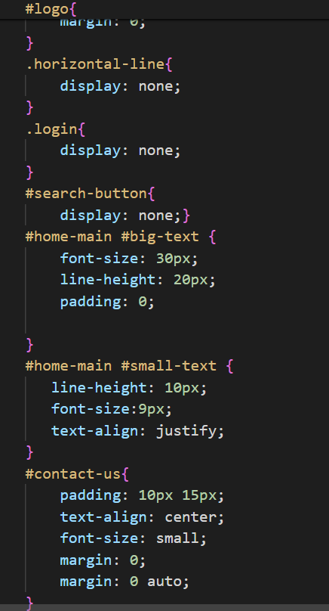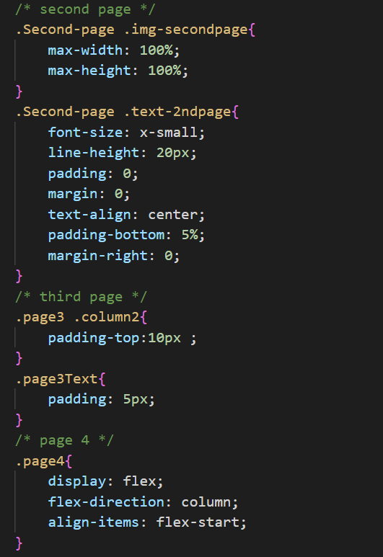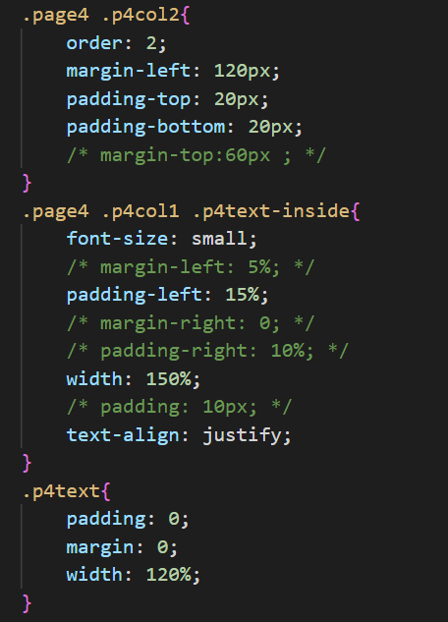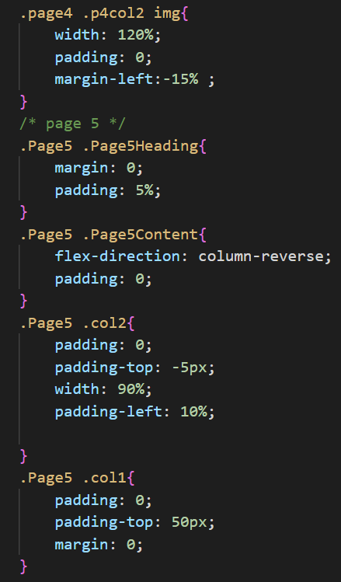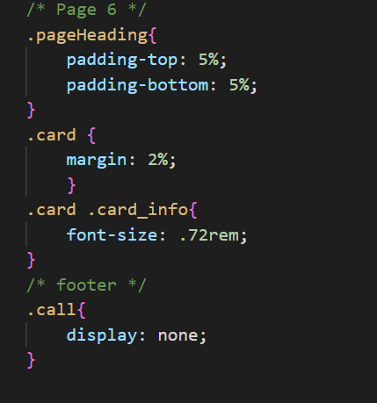

WEBSITE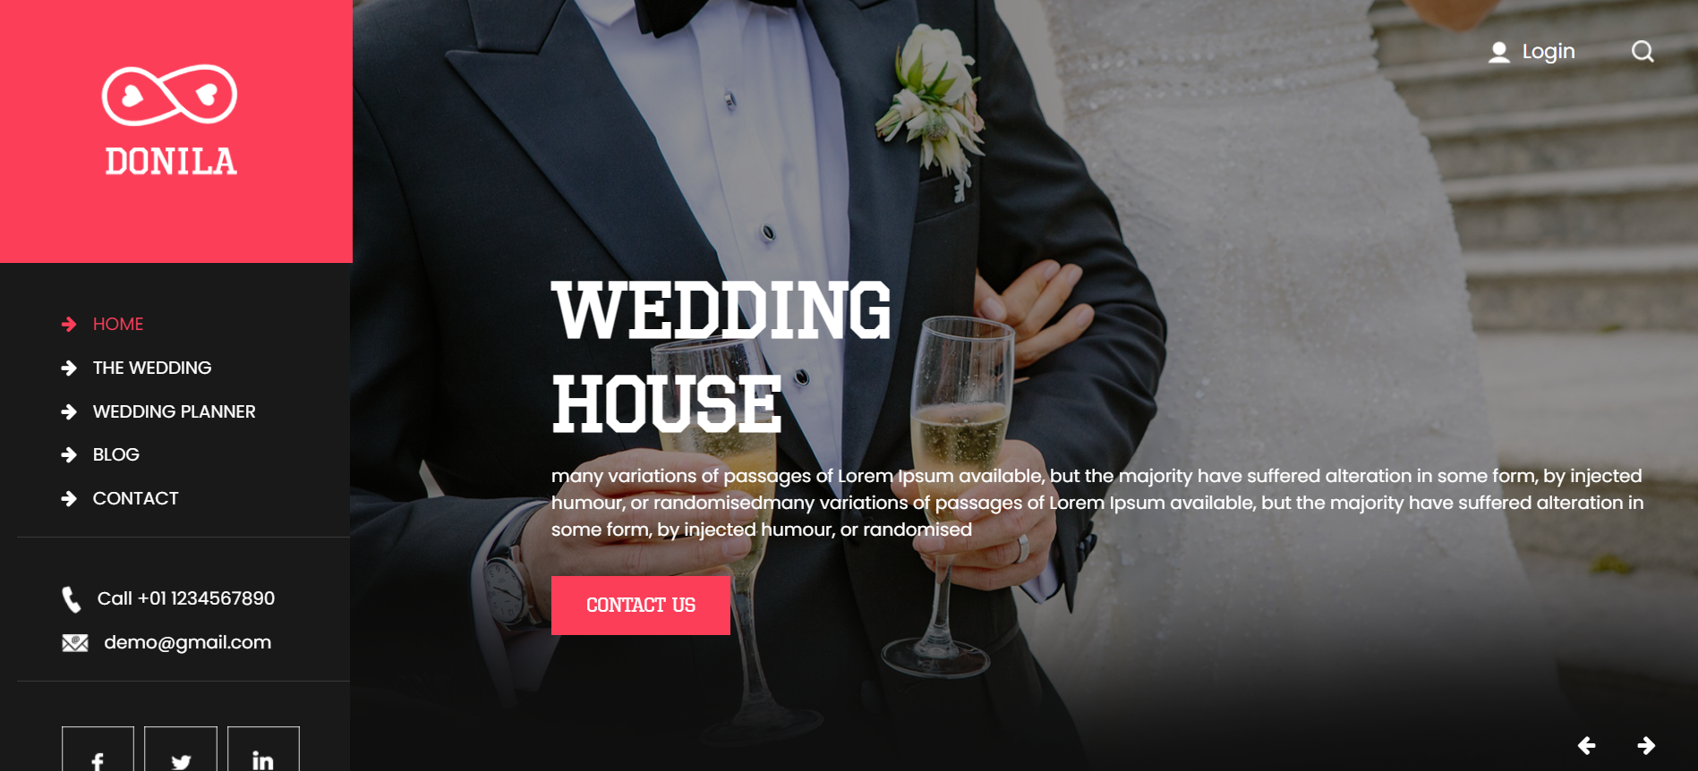

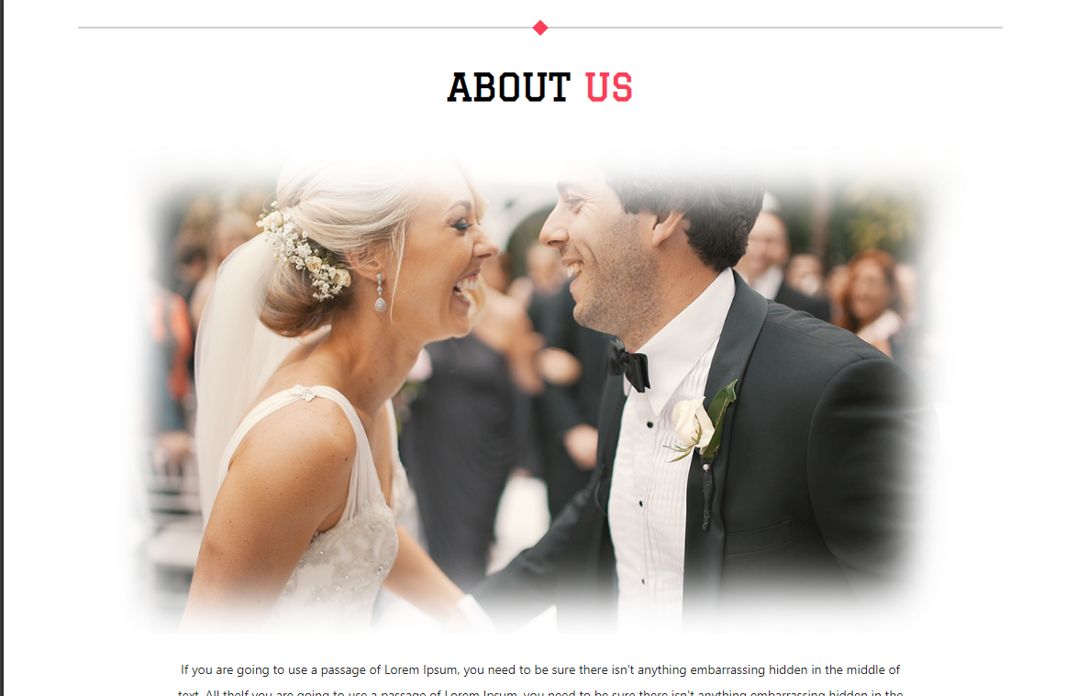

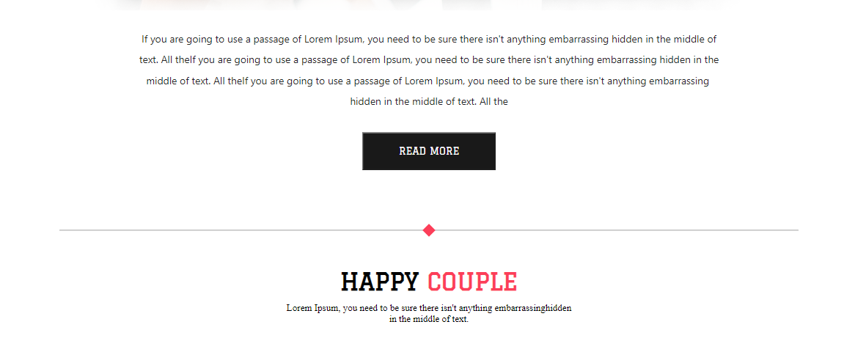

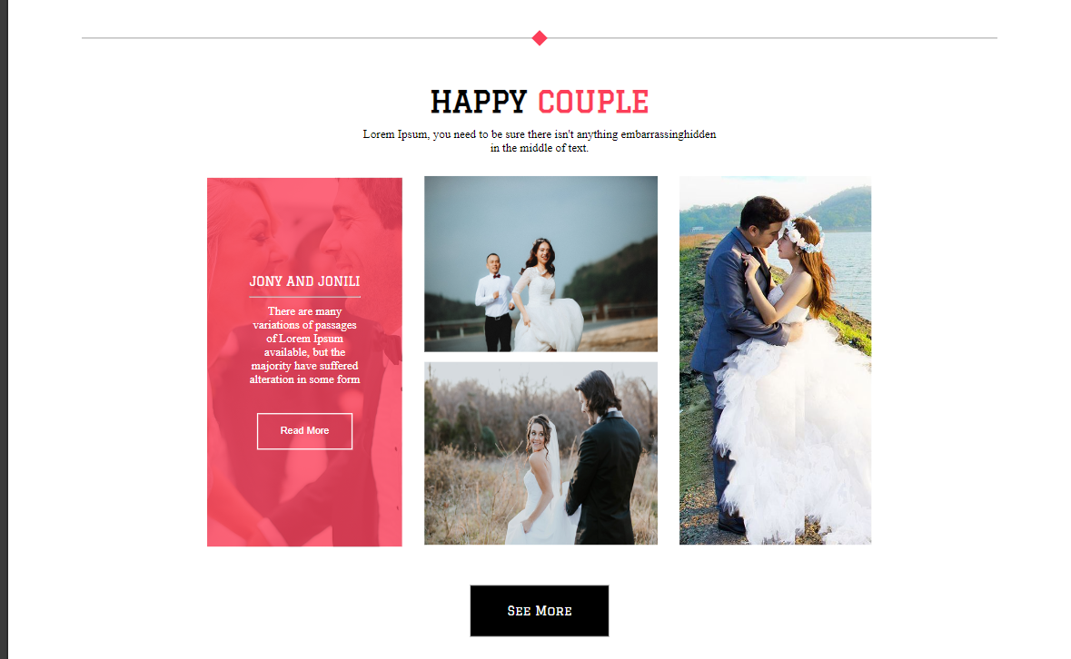

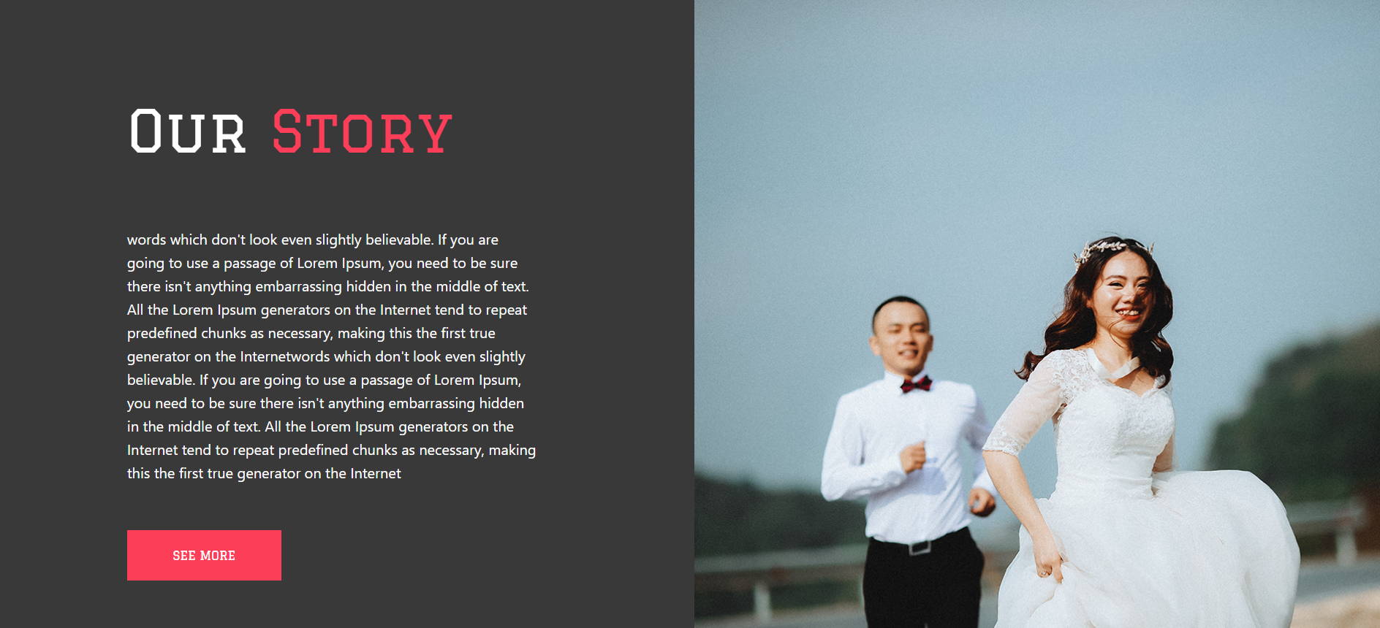

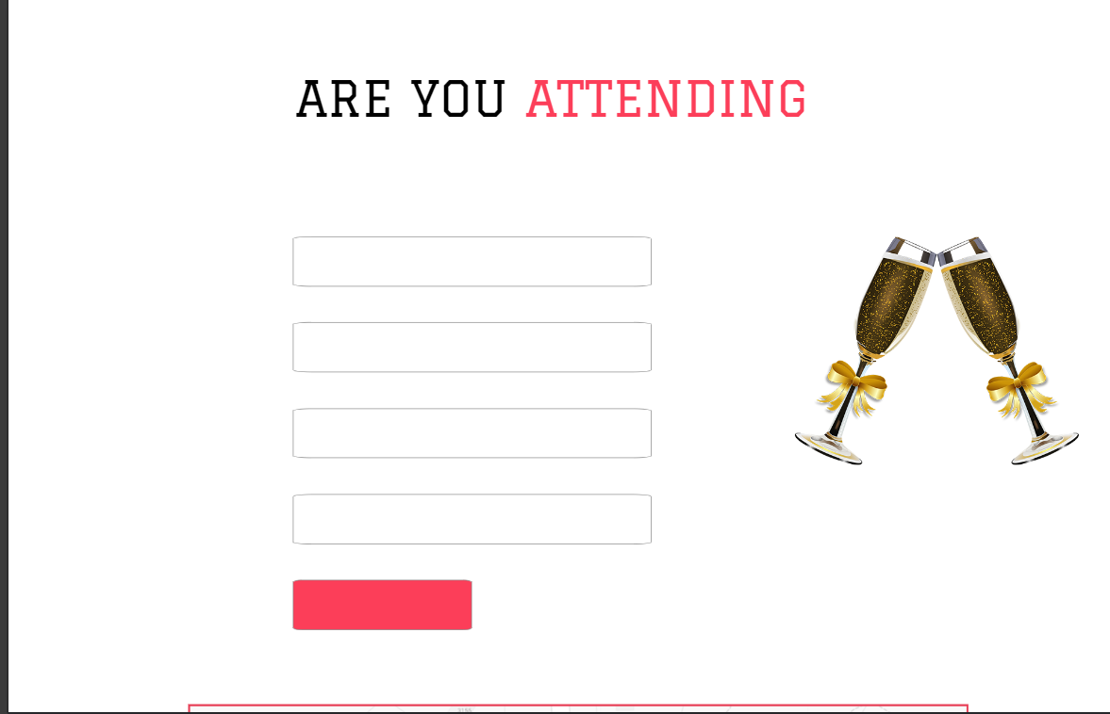

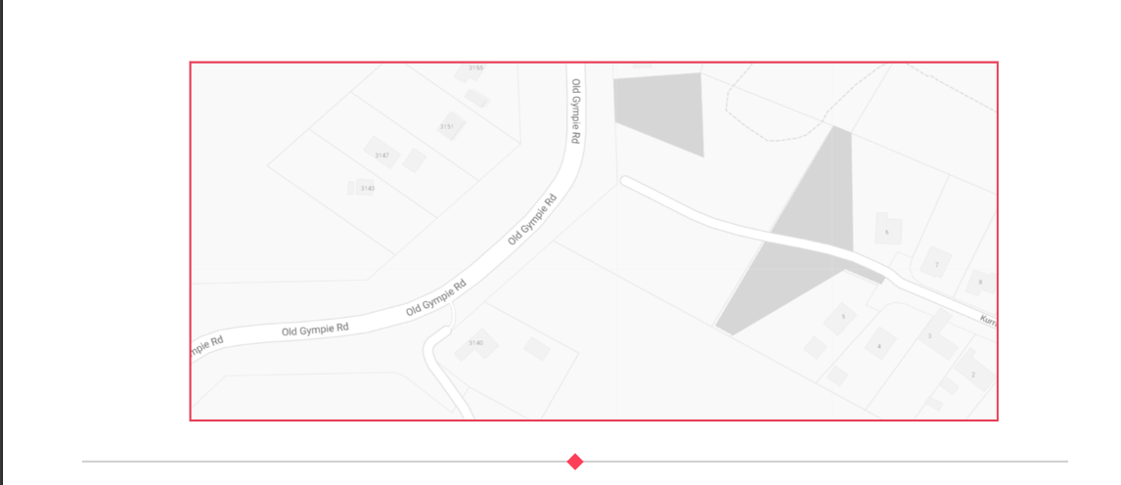

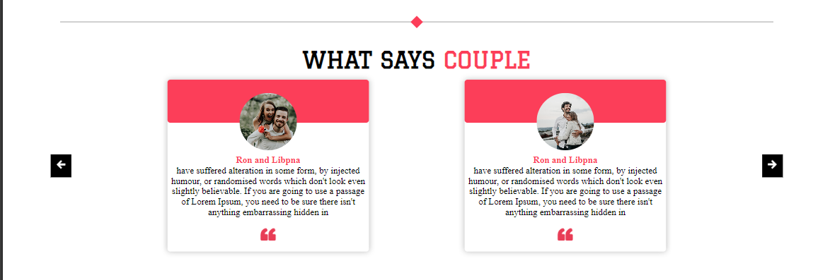



**Responsive**

